Minor Python Project

**Youtube Video Downloader**

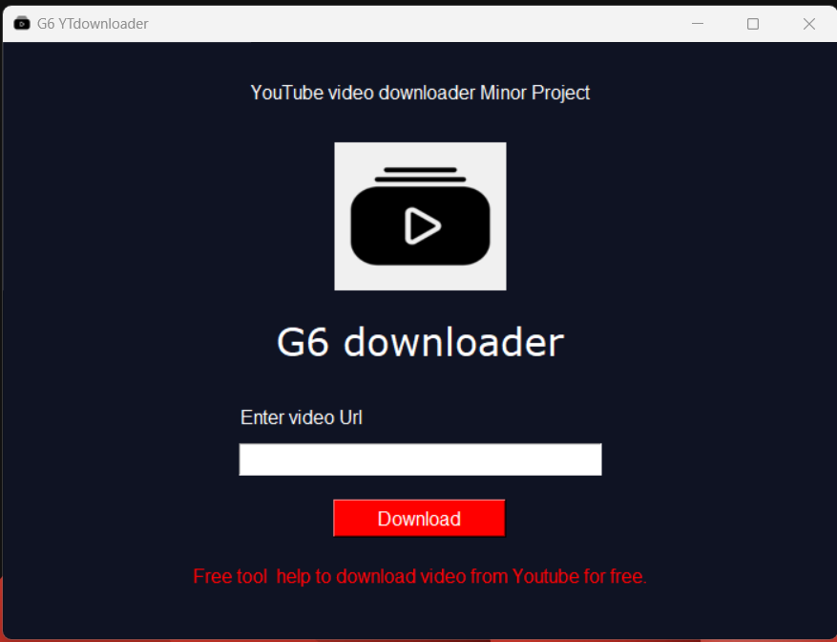

**Aniket Bandral, Tanisha Gandhi, Rikit Kotwal, Abhay Solan**

Group - 6

# INTRODUCTION

YouTube is a very popular video sharing website. Downloading a video from YouTube is a tough job. Download the Downloader and get the video using that or go to any other website which fetches the video and saves on your computer. Using Python, this task is very easy. Few lines of code will download the video from YouTube for you. For this, there is a python library named ‘pytube’. pytube is a lightweight, dependency-free Python library which is used for downloading videos from the web. Our main goal is to create a project using pytube and GUI library to build a working model with GUI

Downloading a video’s/playlist from YouTube is a tedious task. Downloading that video through Downloader or trying to download it from a random website increase’s the risk of licking your personal data. Using the Python Tkinter package, this task is very simple-efficient-safe. Few bunch codes will download the video for you. For this, there are two Python libraries – Tkinter and pytube.

# YouTube is an internationally known website for sharing videos. Unfortunately, when you use an online downloader to download a video or try to get it from a random website, you face the danger of your personal information being stolen.

# IMPORTANT POINTS:

* Make sure you are connected to the internet to download the videos. Otherwise it will raise an error.
* Paste Any Youtube Video URL in input box and click on download Button
* Connection Interruption in between will also raise an error and video will not be downloaded in that case.

# 

# REQUIREMENTS

* An understanding of the Python programming language.
* Python package installed on your PC.
* An editor of your choice.
* Tkinter - A Python module for creating GUIs.
* Pytube - Downloads the video from YouTube.

# 

# MODULE REQUIRED

**pytube** :pytube is a lightweight, simple-to-use, dependency-free Python library that is used for downloading videos from the web.pytube, is not an auto-configured library. You need to install it before using it. Installation of pytube is easy when you have pip. In the Terminal or Command Prompt, type the following command to install pytube.

If you are on Mac OS X or Linux, chances are that one of the following two commands will work for you:

*pip install pytube*

*git clone git://github.com/NFicano/pytube.git pytube | cd pytube | python setup.py install*

If you are on Window’s

pip install pytube3

**Tkinter**: Tkinter is a Python binding to the Tk GUI toolkit. It is the standard Python interface to the Tk GUI toolkit or in simple words Tkinter is used as a Python Graphical User interface. Tkinter is the native library, we don’t need to install it externally, just import it.

# 

# INSTALLATION

A Python environment is a foremost requirement for this project. We can follow [these directives](https://www.section.io/engineering-education/introduction-to-virtual-environments-and-dependency-managers/) to set-up a Python environment on our PC. A crucial module needs to be installed, which is the beginning of the development process.

#### 

#### Installing PyTube module

To install Pytube using pip, open your command prompt CLI on your machine and type in the following command.

**pip install PyTube**

#### Install Tkinter

Like PyTube, the pip command is used to install any other Python module. For example, install Tkinter as shown below since it is required to develop the user interface.

pip install Tkinter

#### Building the GUI/API

In this section, we design the interface for the application. Since to build the application downloading functionality, the interface will be minimalistic.

#### 

##### 1. Import Libraries needed in the project

After installing the modules, we need to import the libraries required in our application. Importing them allows them to act as a part of our project. Here is the right way to import them.

# import all Tkinter libraries from the module

from Tkinter import *

# From the installed Pytube module, import the youtube library

from Pytube import YouTube

##### 2. Create the API window

root = Tk()

root.geometry('500 X 300') # Size of the window

root.resizable(0, 0) # makes the window adjustable with its features

root.title('youtube downloader')

root.mainloop()

##### 3. Create the link entry

*#add text*

text1 = Label(root, *text*="G6 downloader",*fg*="white",*bg*="#0F1323")

text1.pack(*padx*=(30))

text1.config(*font*=("verdana",24))

*#input_field_label*

url_label = Label(root, *text*="Enter video Url",*fg*="white", *bg*="#0F1323")

url_label.pack(*pady*=(30,10),*padx*=(0,200))

url_label.config(*font*=(14))

*#input_field_url*

url_input = Entry(root,*width*=50)

url_input.pack(*ipady*=4,*pady*=(0,10))

##### 4. Create the download button

The download button allows you to download the video by calling the download function in the next step. It only takes one line of code, as shown in the code block below.

*#button*

butn = Button(root, *text*="Download", *bg* = "red", *fg*= "white",*width*=15,*height*=1, *command*=yt_download)

butn.pack(*pady*=(10,10))

butn.config(*font*=(21))

The command download is the attribute that initiates the download process when the button is pressed. It is called from the download function created below for getting the video from YouTube.

#### 

##### 5. Creating the download function

Up to this point, you have made a GUI where you can paste your link from youtube, but the download button is not yet functional. So, to fetch the video using the URL, you will have to create a download function called the download button.

The code below is a python function titled download, which reads the URL entered, connects to youtube, and downloads the video. The comments help you know the importance of every line of code and what it does.

def yt_download():

yt_link = url_input.get()

link = YouTube(yt_link)

video = link.streams.get_highest_resolution()

video.download()

messagebox.showinfo("yooo","Video Downloaded Successfully")

#### RUN CODE

Copy and paste a link from a YouTube video to test your API, click the download button. The video is saved in your project folder when logged into a network. The completed GUI is now:

After running the code, the window will appear as shown in the photo below



# CONCLUSION

We have successfully constructed a youtube video downloader application in Python. First, for rendering graphics, we have used the well-known Tkinter package. Next, we used the Pytube library to create a fully functional GUI to fetch videos from Youtube.

# REFERENCES

1. https://www.section.io/engineering-education/youtube-video-downloader-using-python/
2. https://www.geeksforgeeks.org/create-gui-for-downloading-youtube-video-using-python/